If Lincoln had not been assassinated, would the southern states have been treated different in the aftermath of the US civil war? Would the Federal government have rebuilt the economy of the south?
Bruce Carlson, Podcaster, My History Can Beat Up Your Politics. Regular episodes since 2006....
Written Dec 3, 2014
"If I were in your place, I'd let 'em up easy."
Lincoln to General Weitzel at fall of Richmond.
Almost all evidence points to a supposition that Lincoln would have preferred an easier Reconstruction and would have hurried to get states back in the Union. We do not know two things a) if he would have felt the same after all guns were silenced b) if we as moderns would have liked what he did.
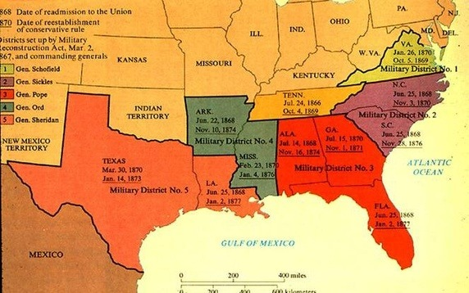
One should look to two actions - his plans for the Reconstruction of Louisiana and his veto of Wade-Davis as clues for his vision.
Lincoln issued a proclamation in Dec 1863 that argued for a low standard for reconstruction to bring states back in as quickly as possible. 10% needed to say an oath and the state needed to ban slavery. White southerners in the Union-occupied state of Louisiana met in 1864—before the end of the Civil War—to draft a new constitution in accordance with the Ten-Percent Plan. The progressive delegates promised free public schooling, improvements to the labor system, and public works projects. They also abolished slavery in the state but refused to give the would-be freed slaves the right to vote. Although Lincoln approved of the new constitution, Congress rejected it.
Congress thought differently. The Wade-Davis bill required a majority of white citizens to swear allegiance. For some states, that may not have happened. One imagines Georgia after Sherman's March to the sea then humming Yankee Doodle.
If a majority could not be had, Wade-Davis provided for the appointment of provisional military governors in the seceded states until a state did. If a majority of a state’s white citizens swore allegiance to the Union, a constitutional convention could be called. Each state had to abolish slavery, repudiate secession, and disqualify Confederate officials from voting or holding office. In order to qualify for the franchise, a person would be required to take an oath that he had never voluntarily given aid to the Confederacy.
Never gave aid to a quasi government that was in place for four bitter years of war? It was the stuff of dreams. Lincoln pocket-vetoed it. (let it die without signing during a recess) and issued this message
Whereas, at the late Session, Congress passed a Bill, 'To guarantee to certain States, whose governments have been usurped or overthrown, a republican form of Government,' a copy of which is hereunto annexed:
And whereas, the said Bill was presented to the President of the United States, for his approval, less than one hour before the sine die adjournment of said Session, and was not signed by him:
And whereas, the said Bill contains, among other things, a plan for restoring the States in rebellion to their proper practical relation to the Union, which plan expresses the sense of Congress upon that subject, and which plan it is now thought fit to lay before the people for their consideration.

Now, therefore, I, Abraham Lincoln, President of the United States, do proclaim, declare, and make known that, while I am, (as I was in December last, when by proclamation I propounded a plan for restoration) unprepared, by a formal approval of this Bill, to be inflexibly committed to any single plan of restoration; and, while I am also unprepared to declare, that the free-state constitutions and governments, already adopted and installed in Arkansas and Louisiana, shall be set aside and held for nought, thereby repelling and discouraging the loyal citizens who have set up the same, as to further effort; or to declare a constitutional competency in Congress to abolish slavery in States, but am at the same time sincerely hoping and expecting that a constitutional amendment, abolishing slavery through the nation, may be adopted, nevertheless, I am fully satisfied with the system for restoration contained in the Bill, as one very proper plan for the loyal people of any State choosing to adopt it; and that I am, and at all times shall be, prepared to give the Executive aid and assistance to any such people, so soon as the military resistence to the United States shall have been suppressed in any such State, and the people thereof shall have sufficiently returned to their obedience to the Constitution and the law of the United States,â€” in which cases, military Governors will be appointed, with directions to proceed according to the Bill.14
In his message, he hinted that he'd rather see states work out their own Reconstruction plan at their level. He is not accepting of one single solution, and he most of all hated that Wade Davis would ruin what had gone on in Louisiana in response to his plan.
So the quick answer is Lincoln would have adopted a softer approach than most of the Republicans in Congress. However, I think there are two questions. When he issued his Proclamation it was 1863. The war was raging still. Gettysburg and Vicksburg had happened but Atlanta had not yet. His total focus, expounded many times, was to win the war. Could we interpret that Lincoln was merely giving sweat treatment to the early caves just like in any standoff one might. Would he, a moderate even, give the same to South Carolina, which was seen as having a larger role in starting the war. If he did feel he'd treat that state any differently, would politics allow them to come in with just a ten-percent swear? I think it's a real question to consider.
Secondly, would Lincoln Reconstruction fared any better? Would these ten percent governments been able to keep order and restore rights? Would we as moderns have liked what they did. When would voting rights have been obtained by black citizens under those governments? Questions to consider as we think about the various reconstructions.

