The Eisenhower Years… Rockin’ Fifties
APUSH Review Guide for AMSCO chapter 27. (or other sources covering the 1950’s)

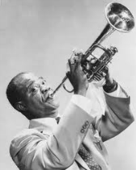
Directions Print document and take notes in the spaces provided. Read through the
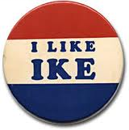
guide before you begin reading. This step will help you focus on the most significant ideas
and information as you read.

From the College Board Content Outline for Period 8
Key Concept 8.1: The United States responded to an uncertain and unstable postwar world by asserting and working to maintain a
position of global leadership, with far-reaching domestic and international consequences.
Key Concept 8.2: New movements for civil rights and liberal efforts to expand the role of government generated a range of political and cultural responses.
Key Concept 8.3: Postwar economic and demographic changes had far-reaching consequences for American society, politics, and culture.

Guided Reading, The Eisenhower Years, 1952-1960, pp 570-584
- Eisenhower Takes Command, pp 570-572

Main Ideas | Definitions/Explanations/Notes | Analysis
After World War II, the United States grappled with prosperity and unfamiliar international responsibilities, while struggling to live up to its ideals.  Cold War policies led to continued public debates over the power of the federal government, acceptable means for pursuing international and domestic goals, and the proper balance between liberty and order. | The Eisenhower Years, 1952-1960 (1st paragraph of chapter)…  Eisenhower Takes Command…  The Election of 1952…  Campaign Highlights… | Why was America ready for a Republican again?  What role did the Korean War play in this shift?
…continued from previous page…

Main Ideas | Definitions/Explanations/Notes | Analysis
After World War II, the United States grappled with prosperity and unfamiliar international responsibilities, while struggling to live up to its ideals.  Cold War policies led to continued public debates over the power of the federal government, acceptable means for pursuing international and domestic goals, and the proper balance between liberty and order. | Domestic Policies…  Modern Republicanism…  Interstate Highway System…  Prosperity…  The Election of 1956… | Explain what “Modern Republicanism” is.  To what degree did Eisenhower depart from FDR’s New Deal and Truman’s Fair Deal programs?  Explain the connection between containment of communism and the Interstate Highway Act.  Why was Richard Nixon chosen as Eisenhower’s Vice President?

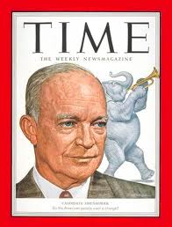
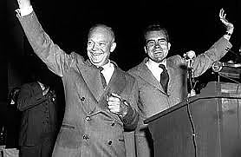
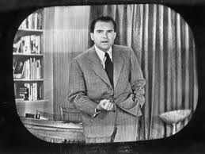
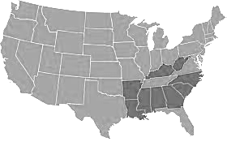
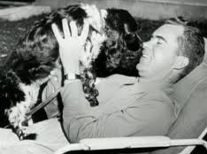
Eisenhower/Nixon won again in 1956 with an even bigger landslide. However, the Democrats controlled both houses.

In 1960, Richard Nixon ran for president but was narrowly defeated by John F. Kennedy. He was later elected President in 1968.
- Eisenhower and the Cold War, pp 572-579

Main Ideas | Definitions/Explanations/Notes | Analysis
The United States developed a foreign policy based on collective security and a multilateral economic framework that bolstered non-Communist nations.  The United States sought to “contain” Soviet-dominated communism through a variety of measures, including military engagements in Korea  As the United States focused on containing communism, it faced increasingly complex foreign policy issues, including decolonization, shifting international alignments and regional conflicts, and global economic and environmental changes.  Postwar decolonization and the emergence of powerful nationalist movements in Asia, Africa, and the Middle East led both sides in the Cold War to seek allies among new nations, many of which remained nonaligned.  Cold War competition extended to Latin America, where the U.S. supported non-Communist regimes with varying levels of commitment to democracy. | Eisenhower and the Cold War…  Dulles’ Diplomacy…  Massive Retaliation…  Unrest in the Third World…  Covert Action… | Support or refute the assertion that John Foster Dulles was a dangerous man with a dangerous approach to foreign policy. Explain your reasoning.  How did covert action in the Third World create conflict in American society?

…continued from previous page…

Main Ideas | Definitions/Explanations/Notes | Analysis
The United States developed a foreign policy based on collective security and a multilateral economic framework that bolstered non-Communist nations.  The United States sought to “contain” Soviet-dominated communism through a variety of measures, including military engagements in Korea and Vietnam.  As the United States focused on containing communism, it faced increasingly complex foreign policy issues, including decolonization, shifting international alignments and regional conflicts, and global economic and environmental changes.  Postwar decolonization and the emergence of powerful nationalist movements in Asia, Africa, and the Middle East led both sides in the Cold War to seek allies among new nations, many of which remained nonaligned.  Cold War competition extended to Latin America, where the U.S. supported non-Communist regimes with varying levels of commitment to democracy. | Asia…  Korean Armistice…  Fall of Indochina…  Division of Vietnam…  SEATO…  The Middle East…  Suez Crisis…  Eisenhower Doctrine…  OPEC and Oil… | Support or refute the assertion that the United States won the Korean War.  Explain domino theory.  How does domino theory relate to containment?  To what extent was securing oil supplies responsible for the Eisenhower Doctrine? Explain your reasoning.  Why was the nation of Israel created in 1948?  Explain the key difference between the Truman Doctrine and the Eisenhower Doctrine?

…continued from previous page…

Main Ideas | Definitions/Explanations/Notes | Analysis
The United States developed a foreign policy based on collective security and a multilateral economic framework that bolstered non-Communist nations.  As the United States focused on containing communism, it faced increasingly complex foreign policy issues, including decolonization, shifting international alignments and regional conflicts, and global economic and environmental changes.  Postwar decolonization and the emergence of powerful nationalist movements in Asia, Africa, and the Middle East led both sides in the Cold War to seek allies among new nations, many of which remained nonaligned.  Cold War competition extended to Latin America, where the U.S. supported non-Communist regimes with varying levels of commitment to democracy. | U.S. – Soviet Relations…  Spirit of Geneva…  Hungarian Revolt…  Sputnik Shock…  Second Berlin Crisis…  U-2 Incident…  Communism in Cuba… | Was the diplomatic effort at Geneva successful in reaching its goals? Explain.  Did the rejection of Open Skies prevent Americans and Soviets from aerially spying on one another?  How did Sputnik impact Americans?  Compare United States reaction in Hungary to the second Berlin crisis two years later (1958).  Compare Eisenhower’s approach to Cuba to Obama’s.
…continued from previous page…

Main Ideas | Definitions/Explanations/Notes | Analysis
The United States developed a foreign policy based on collective security and a multilateral economic framework that bolstered non-Communist nations.  The United States responded to an uncertain and unstable postwar world by asserting and attempting to defend a position of global leadership, with far-reaching domestic and international consequences. | Eisenhower’s Legacy…  “Military-Industrial Complex”… | Was Dwight Eisenhower an effective President? List at least 3 pieces of evidence to support your answer.

- The Civil Rights Movement, pp 579-581

Main Ideas | Definitions/Explanations/Notes | Analysis
Seeking to fulfill Reconstruction-era promises, civil rights activists and political leaders achieved some legal and political successes in ending segregation, although progress toward equality was slow and halting.  Following World War II, civil rights activists utilized a variety of strategies — legal challenges, direct action, and nonviolent protest tactics — to combat racial discrimination.  Decision-makers in each of the three branches of the federal government used measures including desegregation of the armed services and Brown v. Board of Education. | The Civil Rights Movement…  Origins of the Movement…  Changing Demographics…  Changing Attitudes in the Cold War…  Desegregating the Schools…  Brown Decision…  Resistance in the South… | FDR desegregated war industries.  Truman desegregated the armed forces. Eisenhower sent the National Guard to Little Rock and signed two Civil Rights laws. Which of these three presidents was most influential in the increasing momentum of the Civil Rights movement? Defend your answer.

…continued from previous page…

Main Ideas | Definitions/Explanations/Notes | Analysis
Seeking to fulfill Reconstruction-era promises, civil rights activists and political leaders achieved some legal and political successes in ending segregation, although progress toward equality was slow and halting.  Following World War II, civil rights activists utilized a variety of strategies — legal challenges, direct action, and nonviolent protest tactics — to combat racial discrimination. | Montgomery Bus Boycott…  Federal Laws…  Nonviolent Protests…  Immigration Issues in the Postwar Years… | Compare the tactics of the SCLC to those of the NAACP. Identify a similarity and a difference.  Compare the Chinese Exclusion Act of the Gilded Age to Operation Wetback of the post WWII era.

- Popular Culture in the Fifties, pp 581-583

Main Ideas | Definitions/Explanations/Notes | Analysis
Rapid economic and social changes in American society fostered a sense of optimism in the postwar years, as well as underlying concerns about how these changes were affecting American values. | Popular Culture in the Fifties…  Consumer Culture and Conformity…  Television… | How were the 50s similar to the 20s?
…continued from previous page…

Main Ideas | Definitions/Explanations/Notes | Analysis
Rapid economic and social changes in American society fostered a sense of optimism in the postwar years, as well as underlying concerns about how these changes were affecting American values.  A burgeoning private sector, continued federal spending, the baby boom, and technological developments helped spur economic growth, middle-class suburbanization, social mobility, a rapid expansion of higher education, and the rise of the “Sun Belt” as a political and economic force.  These economic and social changes, in addition to the anxiety engendered by the Cold War, led to an increasingly homogeneous mass culture, as well as challenges to conformity by artists, intellectuals, and rebellious youth. | Advertising…  Paperbacks and Records…  Corporate America…  Religion…  Women’s Roles…  Social Critics…  Novels…  “Beatniks”… | Compare Beatniks to the Lost Generation. What was each group’s source of disillusionment?

- HISTORICAL PERSPECTIVES: A Silent Generation? Page 583- 584

After reading the closing sentiments on the page 593, summarize in your own words the historical significance of the 1950s.

- In 1959, with Eisenhower as president, Alaska and Hawaii joined the Union. The final two states, the two were the first non-contiguous states to be added to the Union. Can you label all 50 states? Highlight the original 13 states.
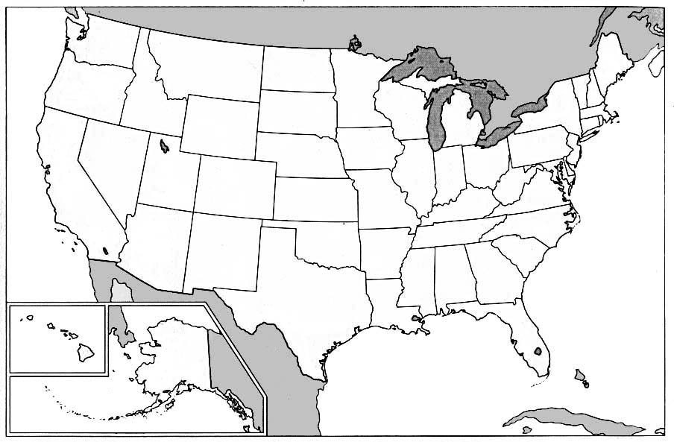

- During the Eisenhower years, U.S. foreign policy led to many interventions globally. Label and color each nation Eisenhower intervened in, and highlight these one color. Then, label the Soviet Union, Great Britain, France, and the oceans.
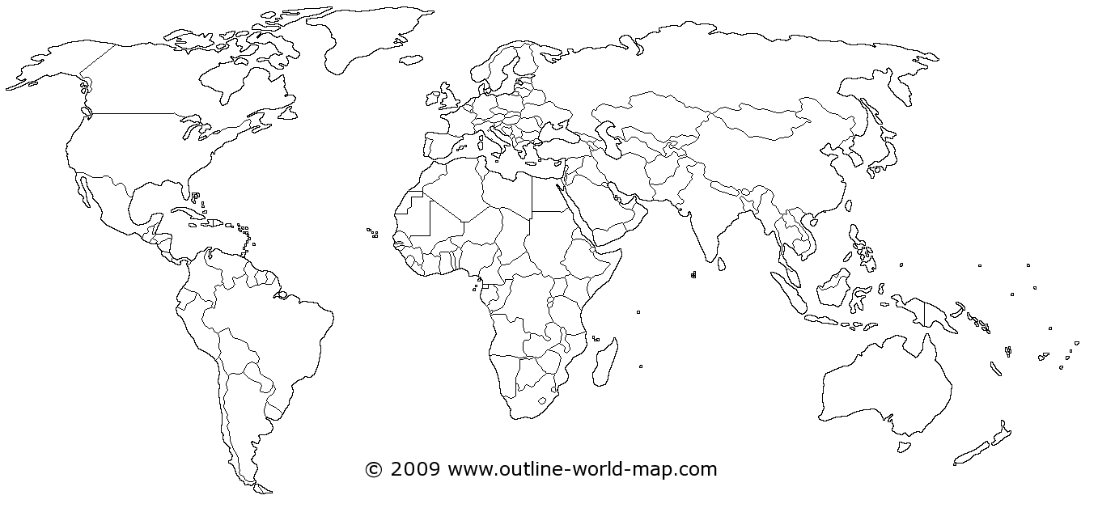

Reading Guide written by Rebecca Richardson, Allen High School
Sources include but are not limited to: 2015 edition of AMSCO’s United States History Preparing for the Advanced Placement Examination,
maps and images from Wikipedia.org and outline-world-map.com, and the 2012 & 2015 Revised College Board Advanced Placement United States History Framework

